**Preparation and Maintenance of ZOHO Books for Bright Ideas Consulting**

**Project Team members: MADHUMITHA.R, MEENATCHI.M, NAGALAKSHMI.K, NOORI AYSHA.T.S**

**1. INTRODUCTION**

**1.1 Overview:**

This project is deal with Bright Ideas Consulting, a consulting firm, relies on Zoho Books to track their billable hours, expenses, and client invoices. The software helps them accurately calculate project costs, monitor profitability, and generate reports for better financial management.

Bright Ideas Consulting is a Private Limited company also registered under GST in Tamil Nadu. Bright Ideas Consulting offers various expert consulting services in India and outside India.

**1.2 Purpose:**

By maintenance of accounts in ZOHO Books, We have created the Items, Vendors creation, Preparation of Purchase Order, Purchase Invoice, Customer creation, Preparation of Sales order, Sales Invoice, creation of bank account, creation of new accounts, recording journal entries, recording expenses, recording bank receipts and payments and viewing of financial reports like Profit & Loss account, Balance sheet, GST Reports, Journal report, Account receivable summary report, Account payable summary report, etc.,

**2. Problem Definition & Design Thinking**

2.1 Empathy Map

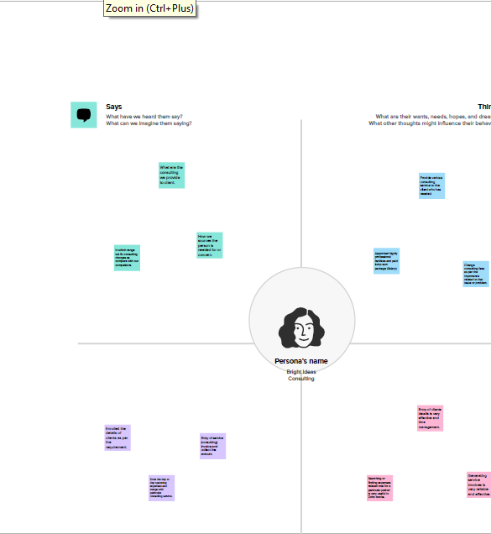

2.2 Ideation & Brainstorming Map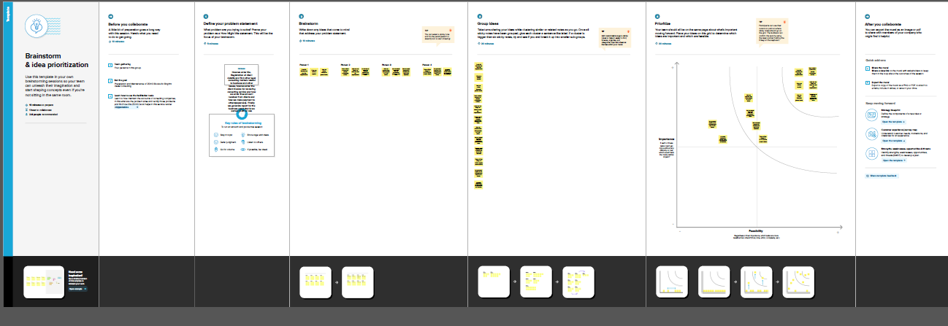

**3. RESULT:**

To Generate the Financial Reports:

1. Profit and Loss Account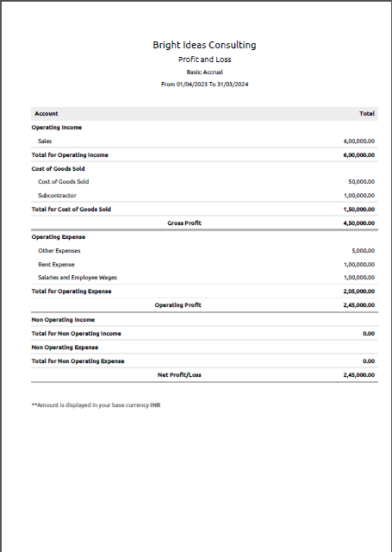
2. Balance Sheet

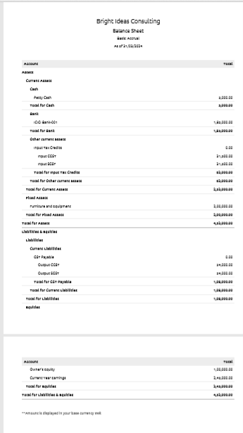

1. GST Reports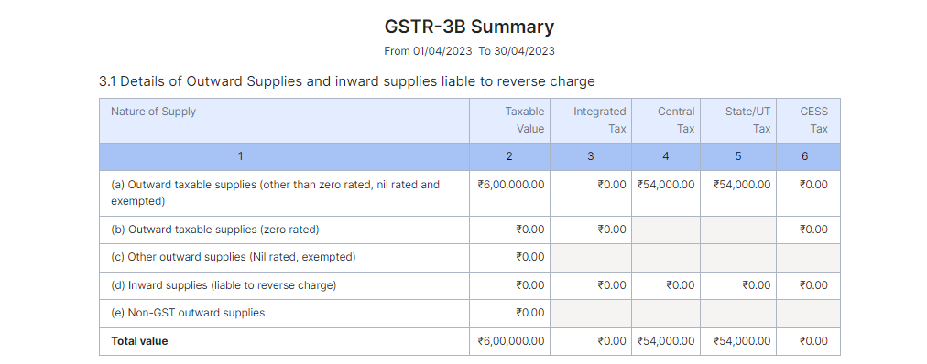

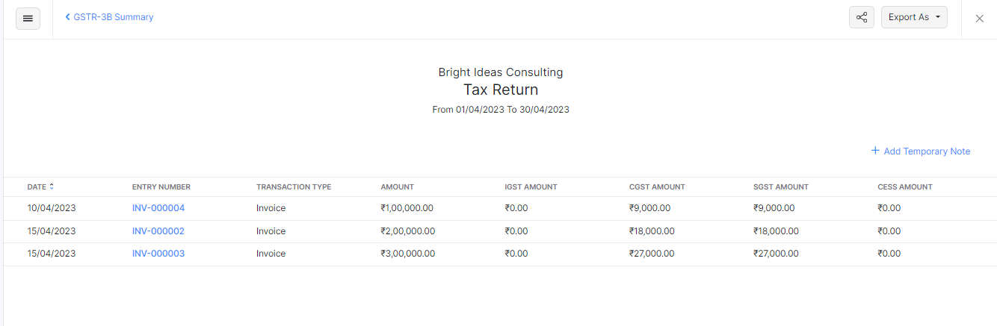

1. Journal Report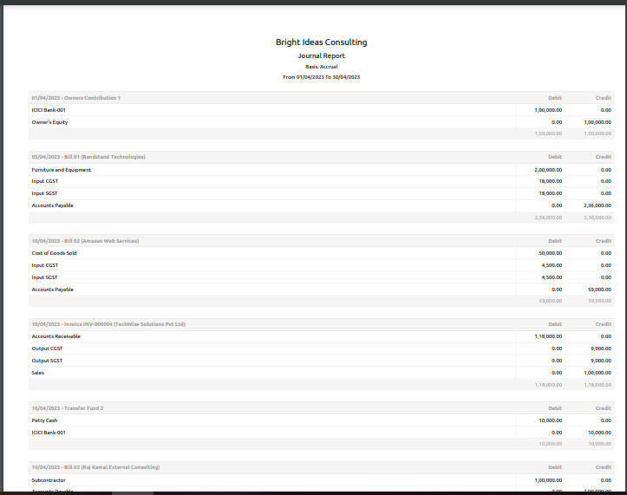

5. Accounts Receivable Summary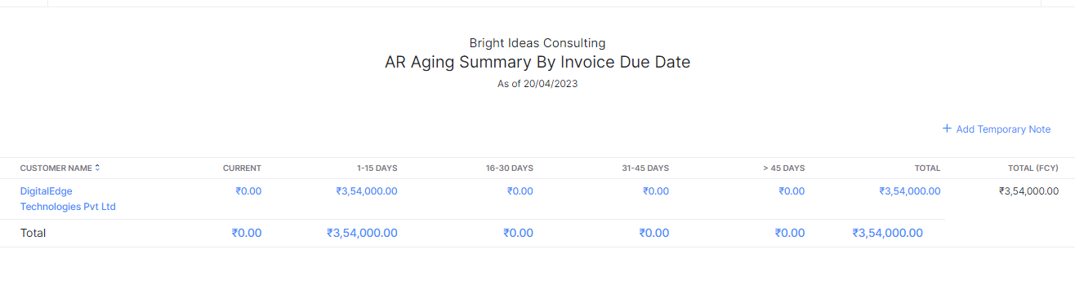

6. Accounts Payable Summary

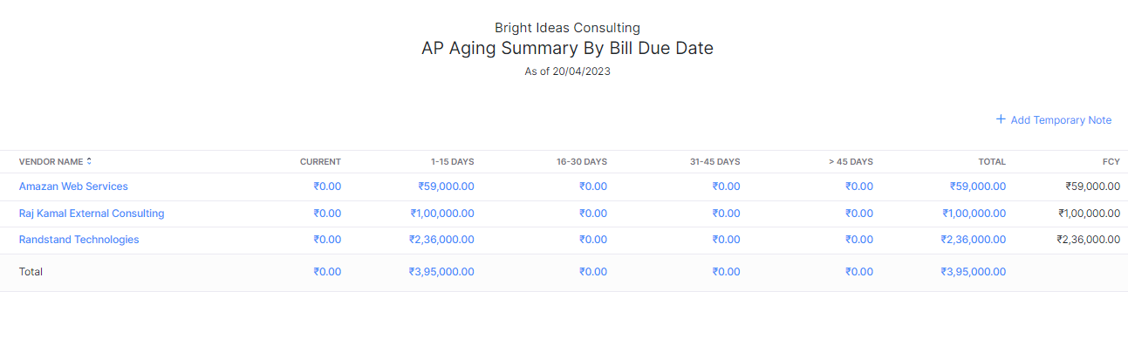

**4. ADVANTAGES & DISADVANTAGES**

List of advantages:

* ZOHO books is cloud based software, so we access the software in any location.
* Creating of Organistion is very easy and user friendly.
* Appearance of software model is very easy to understanding.
* Creation of items, vendors, customers are user friendly while compare with software
* Preparation of purchase order and conversation to purchase Invoice made in a single step.
* Preparation of Sales order and conversation to Sale Invoice made in a single step.
* Default accounting step up is very useful and time saving.
* GST procedure is very easy to enter.
* Getting financial report and tax report in single step.

List of disadvantages:

* ZOHO books is cloud based software, which need internet and other technical facility.
* In absence of internet facility, the working in ZOHO books is very difficult.
* There is no secure in data of the organization.

**5. APPLICATIONS:**

The ZOHO Books is good software in all type of organization and we get better results instantly. We collect the following data and entered in ZOHO Books in various modules like item creation, Vendor creation, customer creation, preparation of Purchase order, Purchase Invoice, sales order, sale Invoice, Making payment to vendors and Expenses, Received amount from Customers.

**Item creation:**

Lets Assume Bright Ideas Consulting is offering below list of various services:

1. Management Consulting

2. Financial Consulting

3. Human Resources (HR) Consulting

4. Legal Consulting

Selling Price for all the above services is say Rs.1000/- per Consulting Hours. Output GST @ 18% is applicable for all the above services.

**Vendor creation:**

1. Randstad Technologies (GST registered)

2. Amazon Web Services (GST registered)

3. Raj Kamal External Consulting (Non GST)

**Customer creation:**

1. TechWise Solutions Pvt Ltd (GST Registered).

2. DigitalEdge Technologies PVT Ltd (GST Registered).

3. SmartTech Innovations (Non GST).

**Preparation of Purchase order, Purchase Invoice:**

1. 05-04-2023 Randstad Technologies – Office Equipment - Qty 20 @ Rs.10,000/- each GST @ 18%

2. 10-04-2023 Cloud Database From Amazon Wed Services- Rs.50,000/- pm GST @ 18%

3. 10-04-2023 Consultancy Services from Raj Kamal External Consulting - Rs.1,00,000/- pm

**Preparation of sales order, sale Invoice:**

1. 10/04/2023 TechWise Solutions Pvt Ltd - 100 Hrs of Financial Consultation - paid through bank on 25/04/2023

2. 15-04-2023 SmartTech Innovations Pvt Ltd- 200Hrs for Financial Consulting

3. 15-04-2023 DigitalEdge Technologies PVT Ltd – 300Hrs for Legal Consulting

**Making payment to vendors and Expenses:**

1. Employee salaries of total Rs.1,00,000/- paid through bank on 30th April 2023.
2. Office Rent Rs.1,00,000/- excluding GST @ 18% Total Invoice Value Rs.1,18,000/- paid through Bank on same day.
3. Other Miscellaneous Expenses Rs.5,000/- paid in cash.
4. 25-04-2023 Paid to Rand Stand Technologies Rs. 2,36,000.
5. 25-04-2023 Paid to Amazon Web Services Rs. 59,000.
6. 25-04-2023 Paid to RajKamal External Consulting Rs. 1,00,000.

|  |  |  |
| --- | --- | --- |
|  |  |  |

**Received amount from Customers:**

1. 12-04-2023 Amount received from Techwise Solutions Rs. 1,18,000.
2. 20-04-2023 Amount received from Smart Tech Innovations Rs. 2,36,000.
3. 25-04-2023 Amount received from DigitalEdge Technologies Rs. 3,54,000.

**6. CONCLUSION:**

In maintain of Bright Ideas Consulting accounts in Zoho books is very smart in all the aspects of entries. The basic accounting concept is enough for the operating person(Accountant/Data entry operator). This software is applicable for all types of organization. The entry models of software are easily understood and interest to work. Whatever reports we need, it’s already default in the report models. Totally it’s a good and very useful to the entire entrepreneur with low cost for operating financial department.

**7. FUTURE SCOPE:**

The idea for the founders of ZOHO Books is amazing and very clever. This is a great milestone in the field of accounts maintenance. They offer various plane as per the requirement of the proprietors. It’s a good gift to all the entrepreneurs.